## COLLEGE OF Engineering – department of computer science

Student name: Razan Almahdi || S20106649

LLMs

1. **Explain what can be done using LLM**

1. Text Generation: LLMs can generate human-like text in response to prompts or questions. They can be used for generating creative writing, storytelling, poetry, and even writing code snippets or technical documentation.

2. Language Translation: LLMs can be employed for translating text from one language to another. By providing input in one language, the model can generate the corresponding translation in the desired language.

3. Question Answering: LLMs can comprehend questions and provide relevant answers based on the information they have been trained on. They can be used for general knowledge queries, FAQ systems, and research assistance.

4. Natural Language Understanding: LLMs can analyze and understand the meaning and context of text inputs. They can extract entities, perform sentiment analysis, and identify key concepts within a given text.

5. Content Summarization: LLMs can summarize long documents or articles into shorter, concise summaries. This can be useful for generating abstracts, condensing information, or providing a quick overview of lengthy text.

6. Chatbot Development: LLMs can serve as the backbone of chatbot systems, engaging in interactive conversations with users. They can understand user queries, provide relevant information, and offer assistance across a wide range of topics.

7. Personal Assistants: LLMs can be used to develop virtual personal assistants that can help with tasks like scheduling appointments, managing to-do lists, answering questions, and providing recommendations.

8. Sentiment Analysis: LLMs can analyze the sentiment expressed in text, determining whether it is positive, negative, or neutral. This can be valuable for social media monitoring, brand reputation management, and customer feedback analysis.

9. Text Classification: LLMs can classify text into different categories or topics. For instance, they can be used to categorize news articles, emails, or customer support tickets based on their content.

10. Language Modeling: LLMs can be fine-tuned on specific domains or datasets to create customized language models. These domain-specific models can then be used for tasks like generating domain-specific content or providing tailored responses.

1. **Provide code of your work, (input data if required)**

Data from kaggle: <https://www.kaggle.com/datasets/stefancomanita/top-us-songs-from-1950-to-2019-w-lyrics?select=topSongsLyrics1950_2019.csv>

Code:

<https://colab.research.google.com/drive/1CjVaA6CpGncWL5nfJ1b1uML4HSFKD21v?usp=sharing>

This code uses a dataset of Top Songs from 1950 to 2019. It finds the top 50 tracks from those years combined, and ranks them in descending order (top to bottom), including: song name, artist name, and year of release for each song.

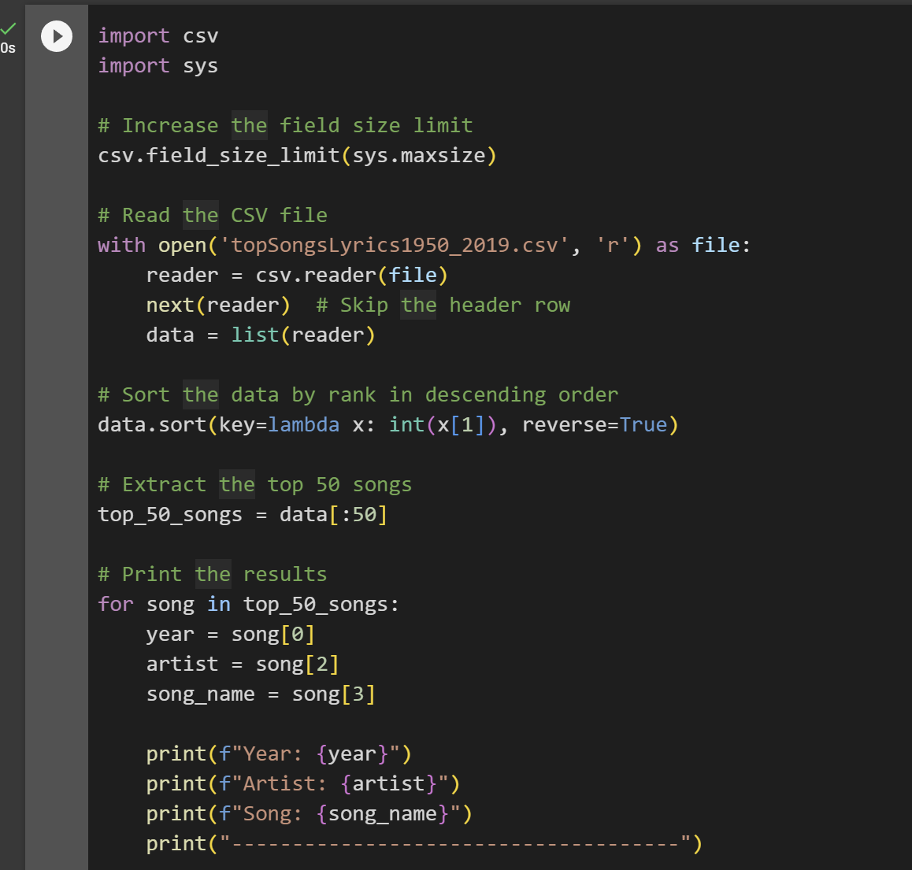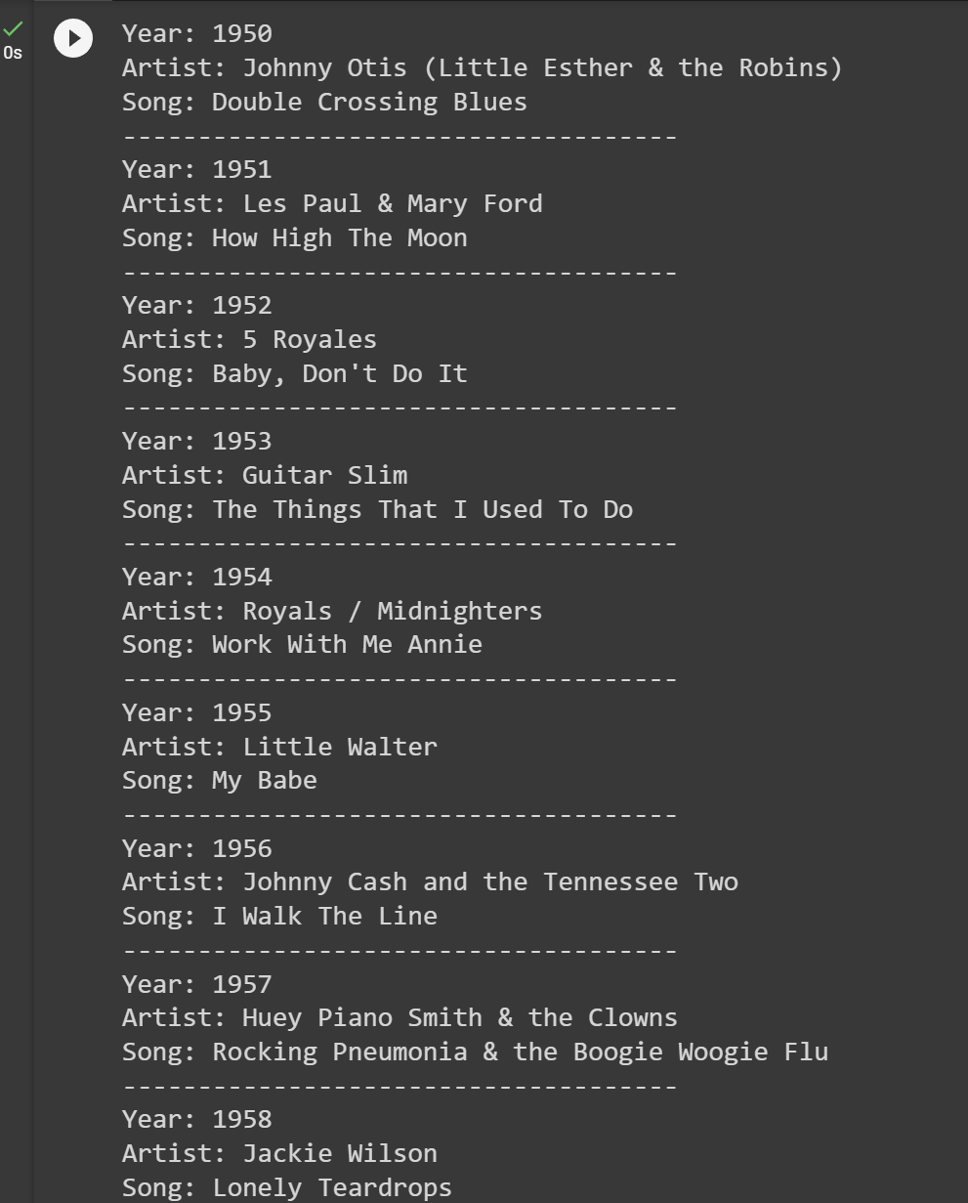

1. References

<https://labelbox.com/blog/how-to-use-llms-to-detect-and-extract-personal-data-from-ai-datasets/>

<https://lightning.ai/pages/community/tutorial/optimizing-llms-from-a-dataset-perspective/>